# Lab: Intro to DOM

Problems for in-class lab for the ["JS Fundamentals Course @SoftUni"](https://softuni.bg/trainings/2247/js-fundamentals-january-2019). Submit your solutions in the SoftUni judge system at <https://judge.softuni.bg/Contests/Practice/Index/1425>

## Register Notification

In this problem, you should **create a JS functionality that** shows notification after successful

registration.

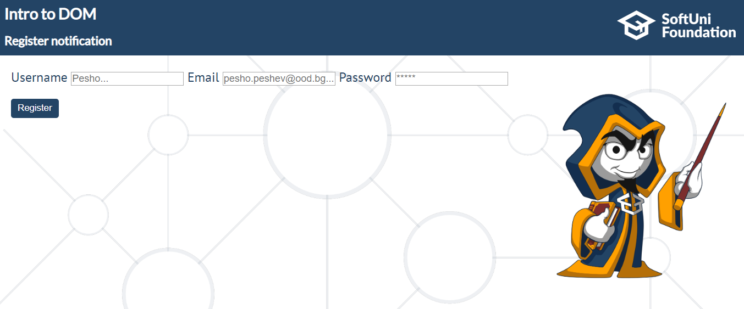

### Constraints:

* The username should be a **non-empty string**
* The email address should match the current RegEx: **/(.+)@(.+).(com|bg)/gm**
* The password should be a **non-empty string**

When these conditions **are met** and after a click on the [**Register**] button, the following

notification should appear for **5000 ms**. *(use the* ***setTimeOut*** *function to do this)*

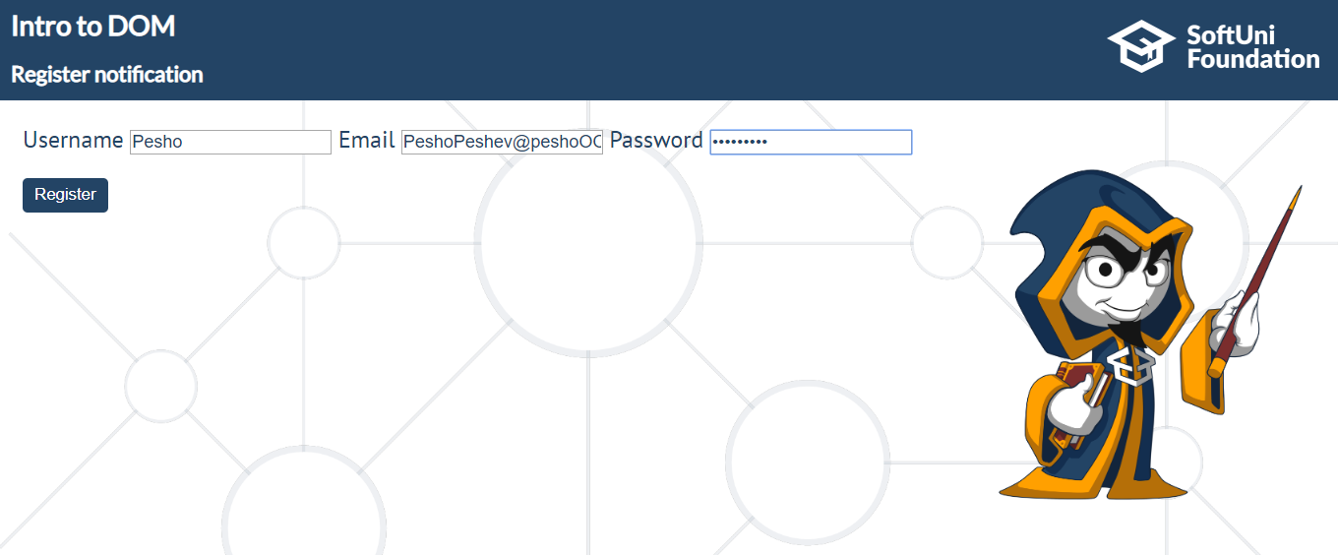

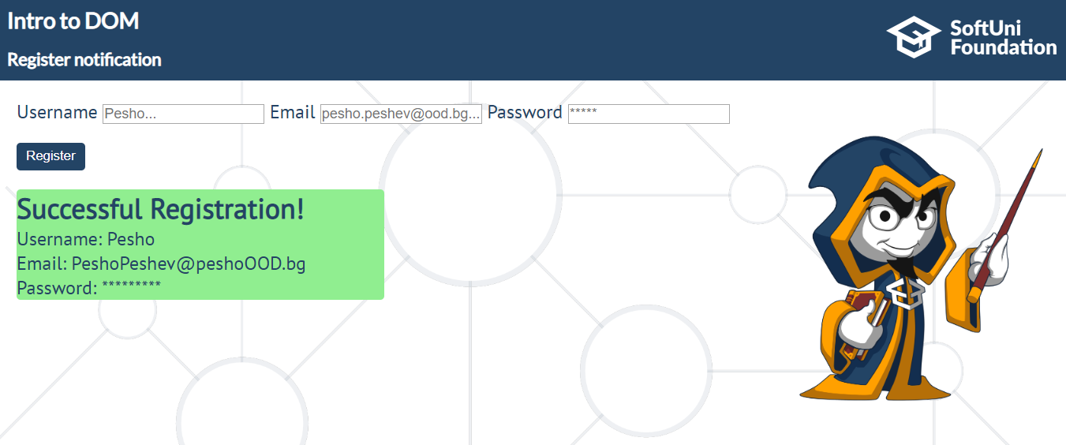

The current information must be added to the section with an **id - result.**

The message should be in the following format:

**'Successful Registration!'** *(must be in h1 tag)*'**Username: ${currentUsername}**'

**'Email: ${currentEmail}'**

**'Password: ${currentPasswordLength in asterixes (*)}'**

